Table of Contents

New users can register in the application after completely filling the form 2

Users are required to completely fill the register form 3

Email validation for the given email 4

Customers can login to their account using a validated email address 5

Attempt to login with wrong password 6

Attempt to login with wrong email address 7

Users can view profile details 8

Users can update profile 8

Users can view products in the shop link 9

Users can filter the products from the product filter 10

Users can search for required products using the search box 11

Users can sort the products on price as high to low or vice-versa 12

Users can add products to their basket 14

Users can update the quantity of products in the basket 15

Users can delete the product from the basket 17

Customers can view the basket with products, quantity and price. 18

Customers can select a collection slot before checking out and edit their details. 19

Customers will receive a receipt of payment for their goods in their email once payment is confirmed 20

## New users can register in the application after completely filling the form

Expected Result: The user is registered

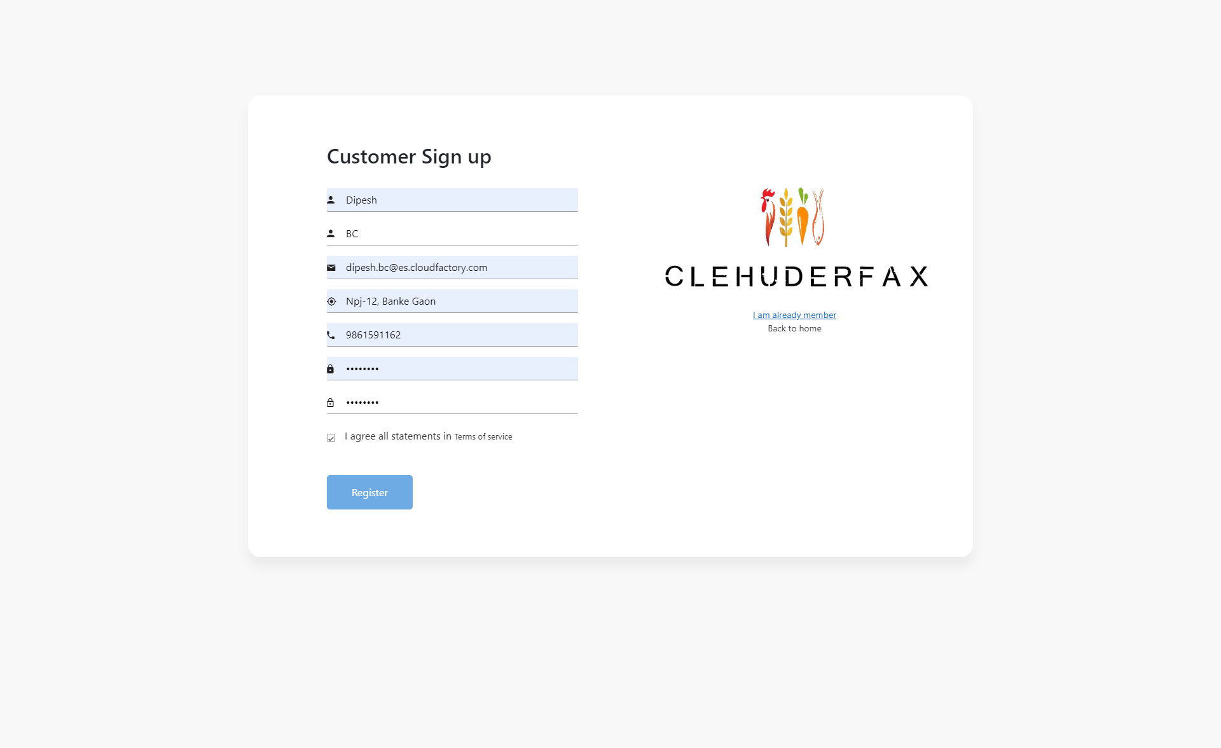

## Users are required to completely fill the register form

Expected Result: If form is incomplete, show error message

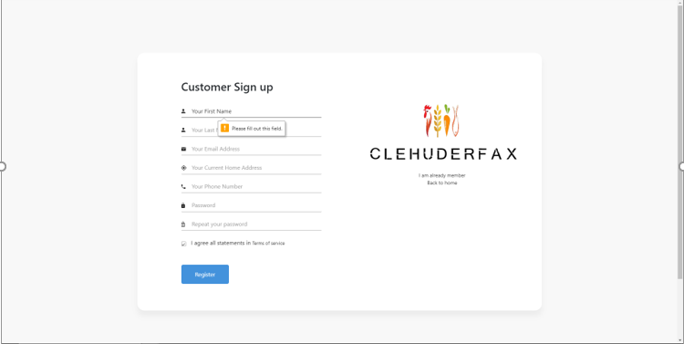

## Email validation for the given email

Expected Result: The user receives an email using which they can validate their email address

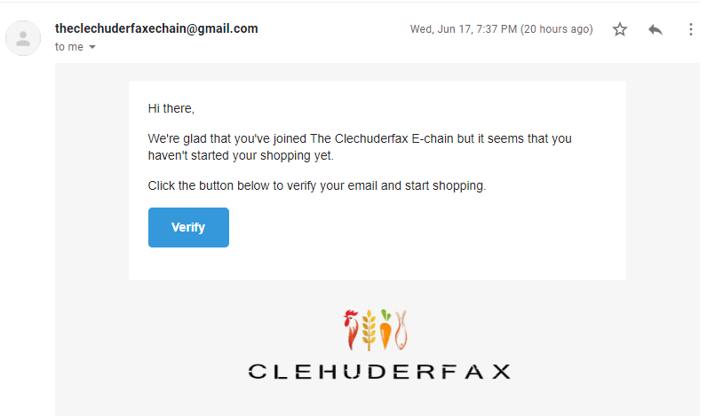

## Customers can login to their account using a validated email address

Expected Result: The user is logged in and redirected to dashboard with successfully logged in notification.

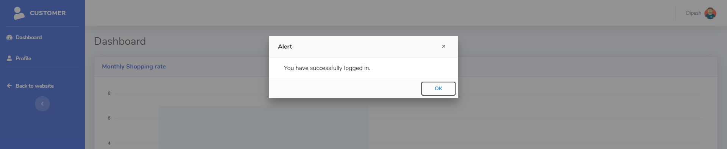

## Attempt to login with wrong password

Expected Result: An error message is shown informing the user of wrong password used

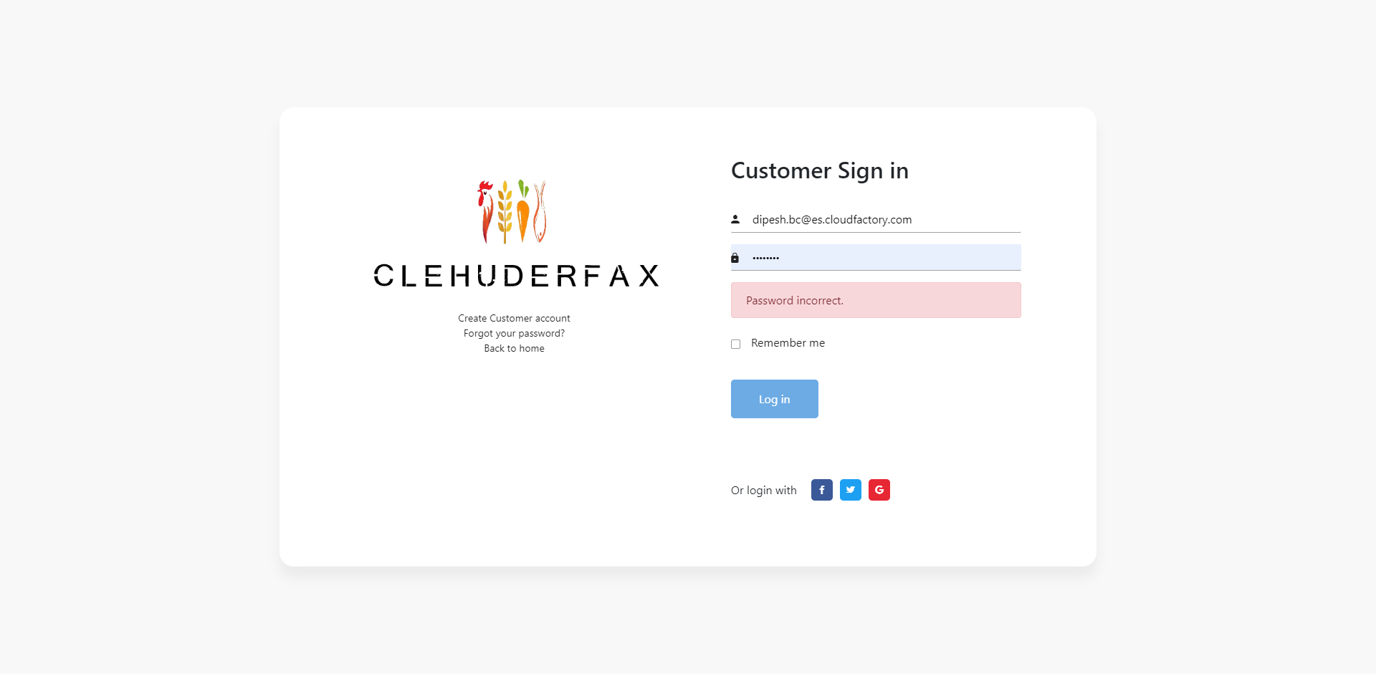

## Attempt to login with wrong email address

Expected Result: User redirected to new user registration page.

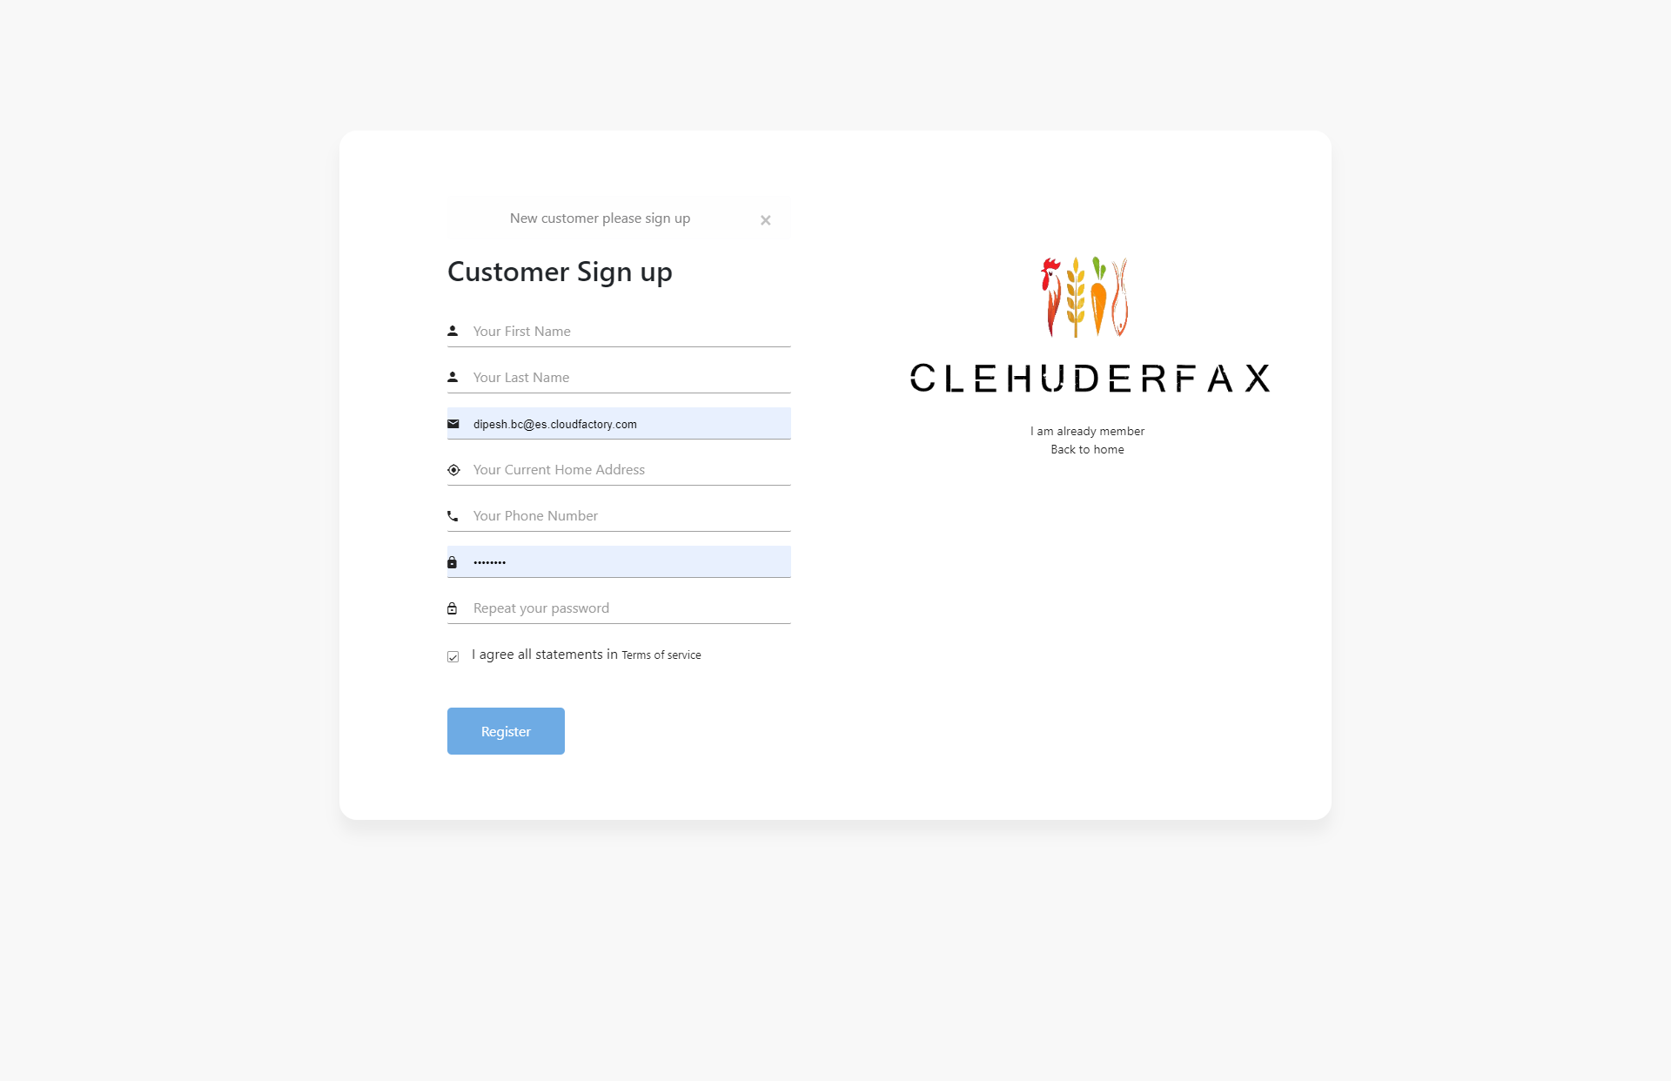

## Users can view profile details

Expected Result: Profile details are shown

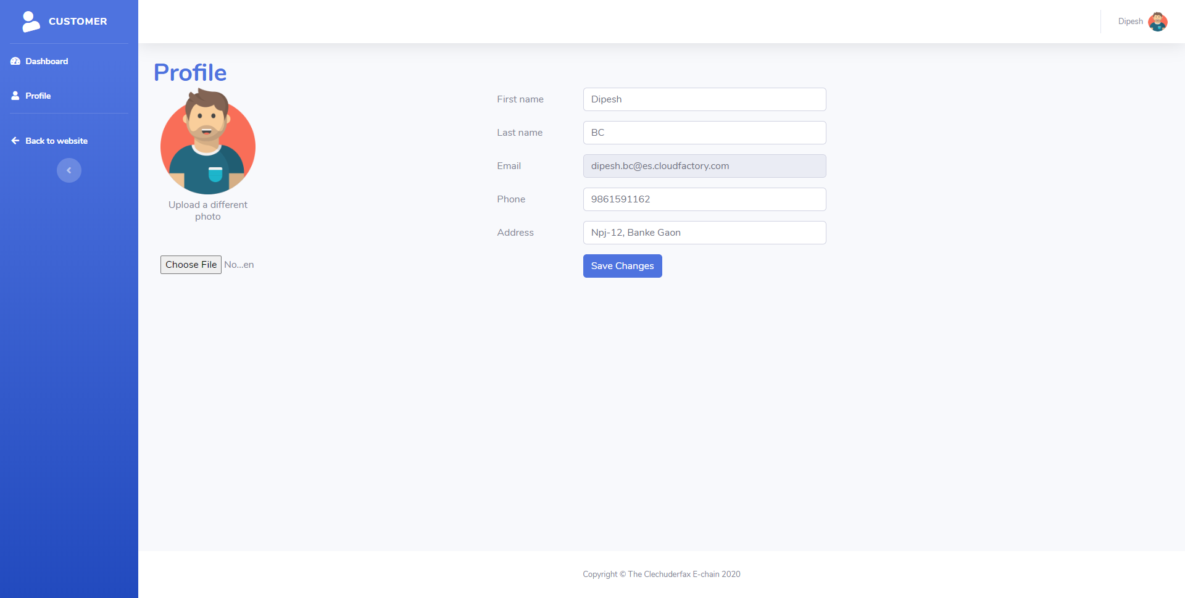

## Users can update profile

Expected Result: Profile is updated

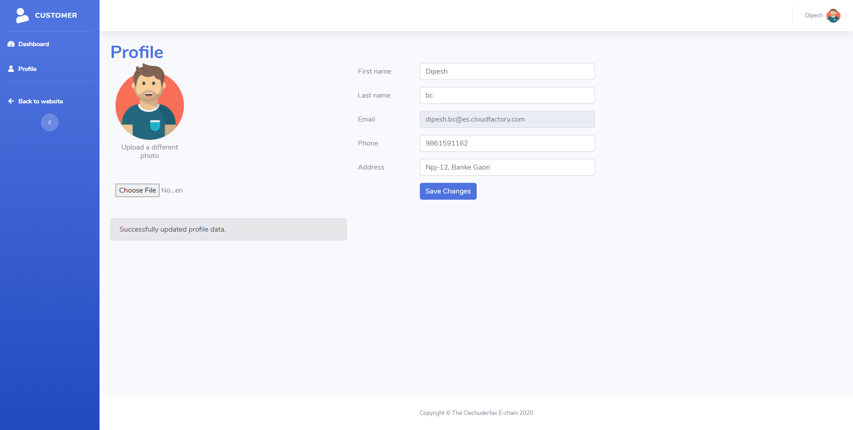

## Users can view products in the shop link

Expected Result: Products are shown

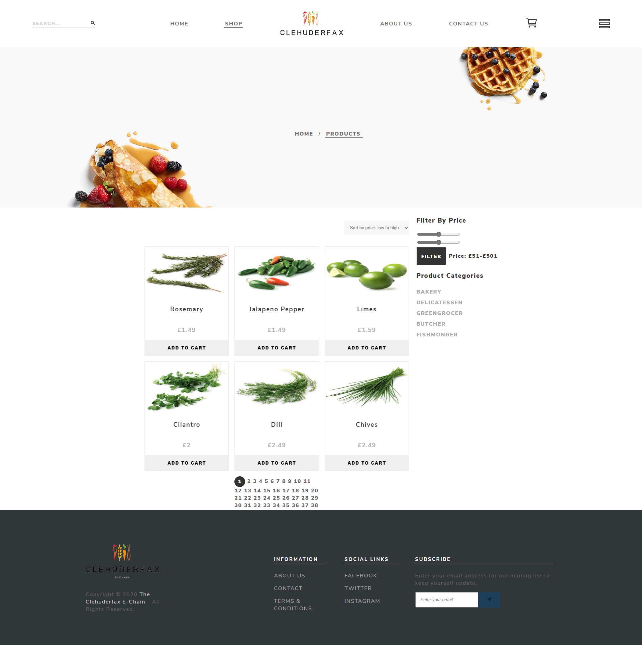

## Users can filter the products from the product filter

Expected Result: Filtered products are shown

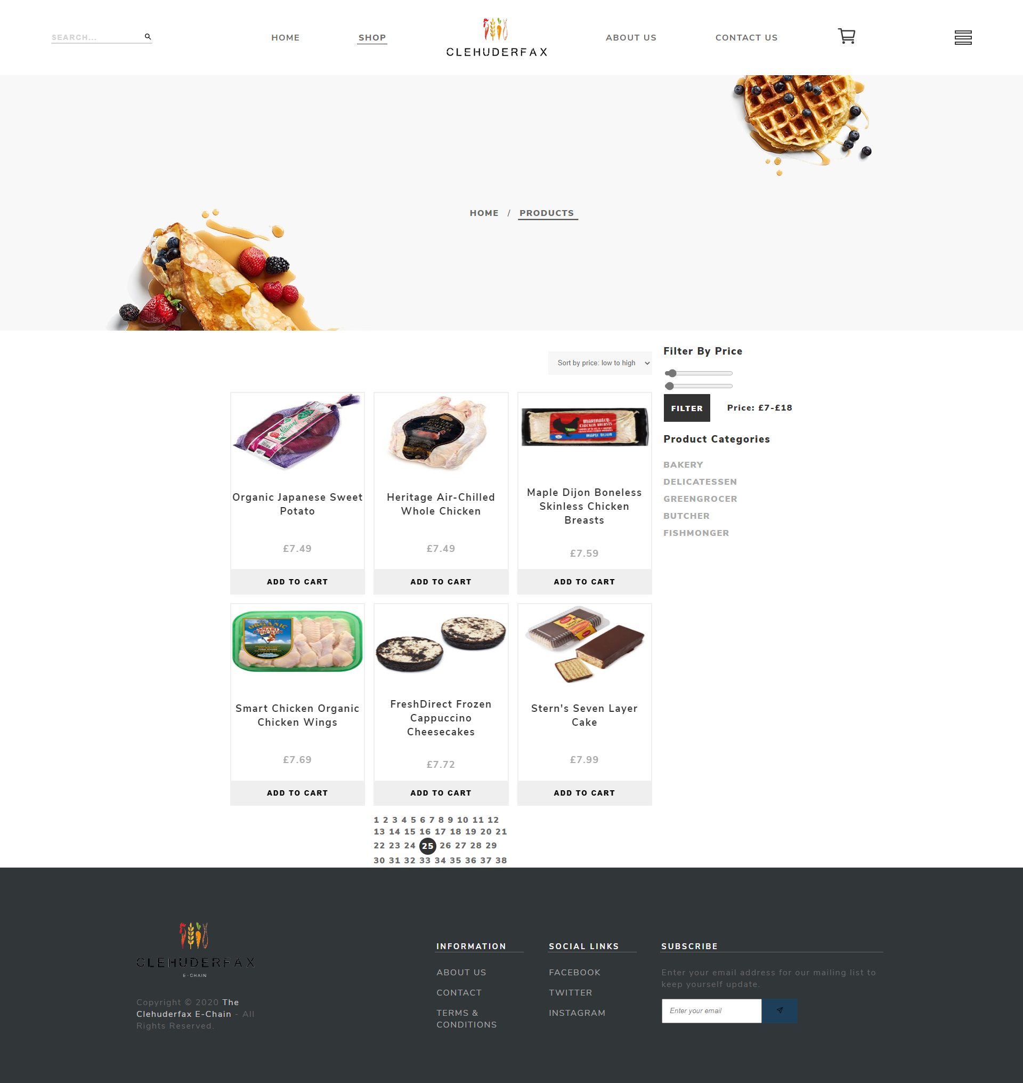

## Users can search for required products using the search box

Expected Result: Matched products are shown in the product search page

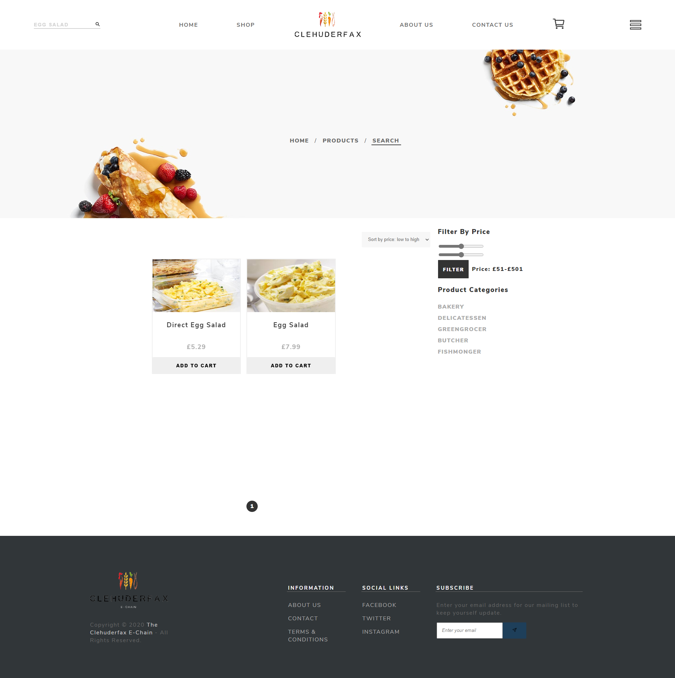

## Users can sort the products on price as high to low or vice-versa

Expected Result: Products in sorted order are shown

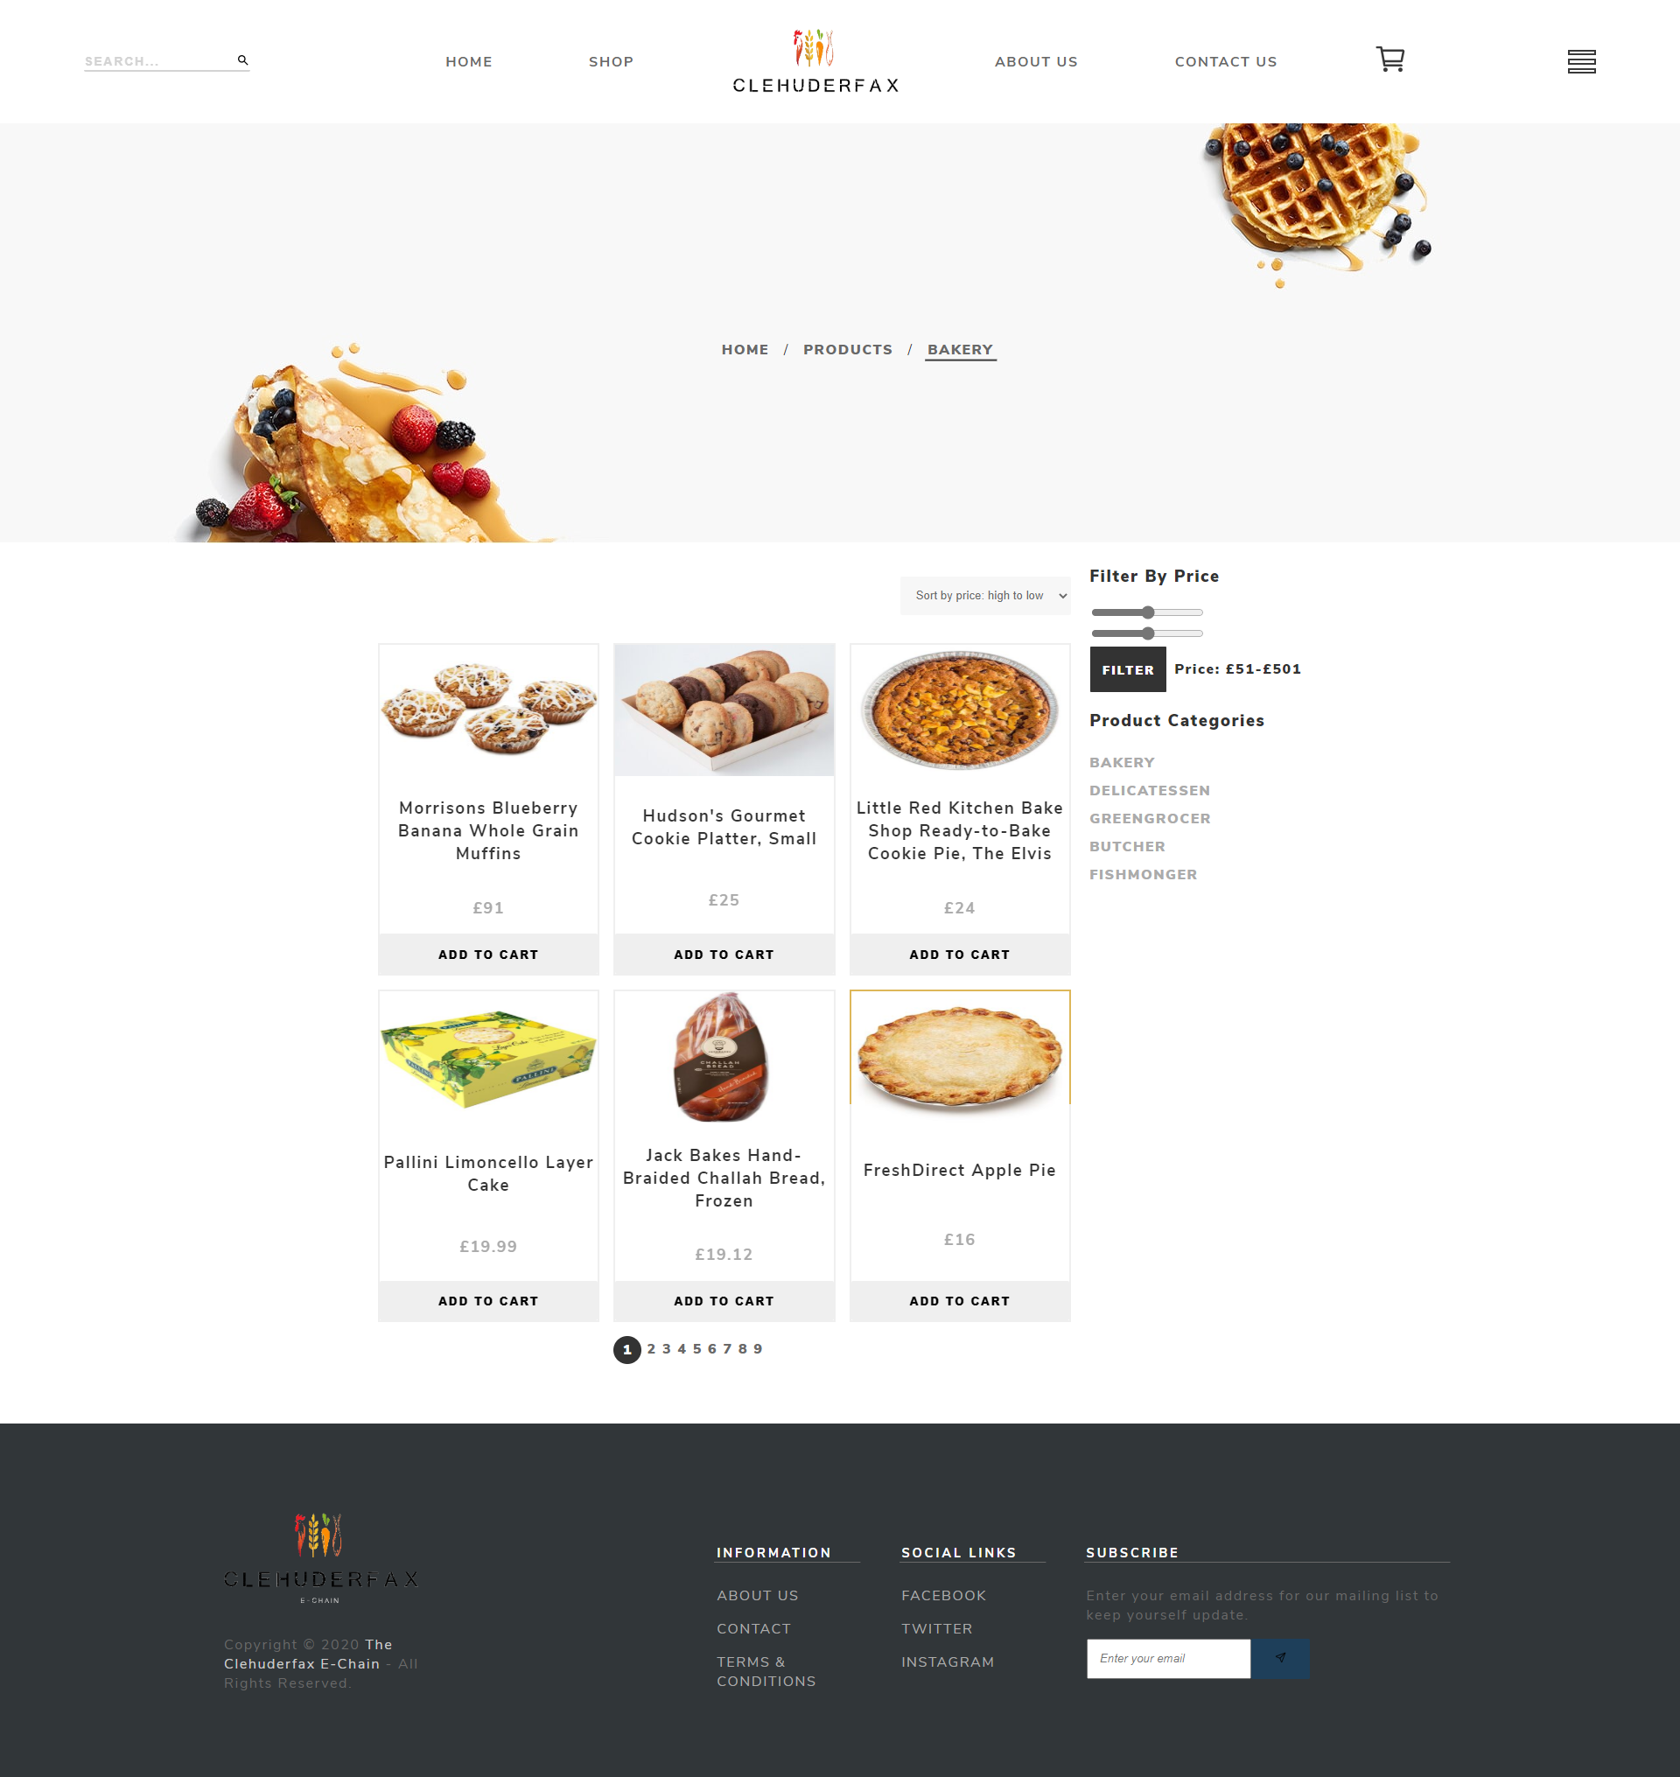

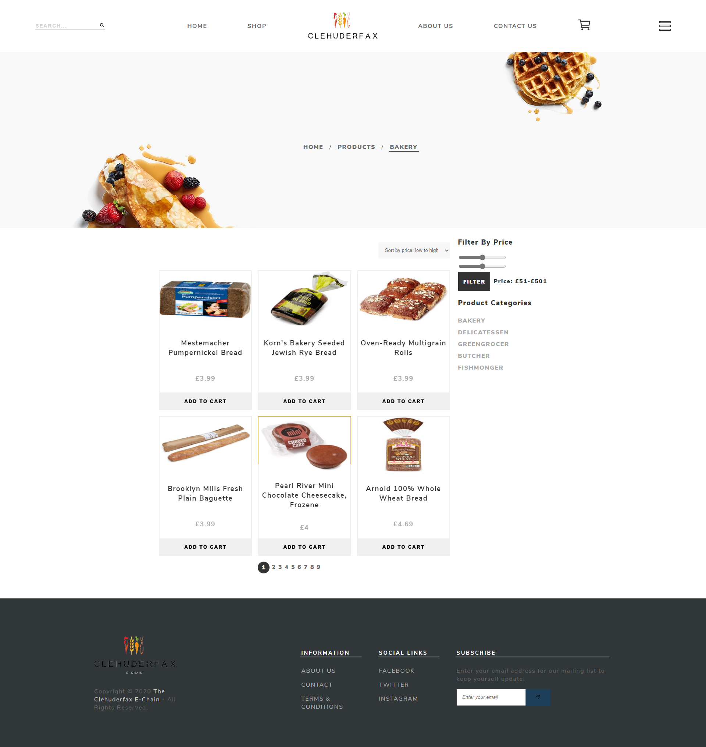

## Users can add products to their basket

Expected Result: Product is added to the basket

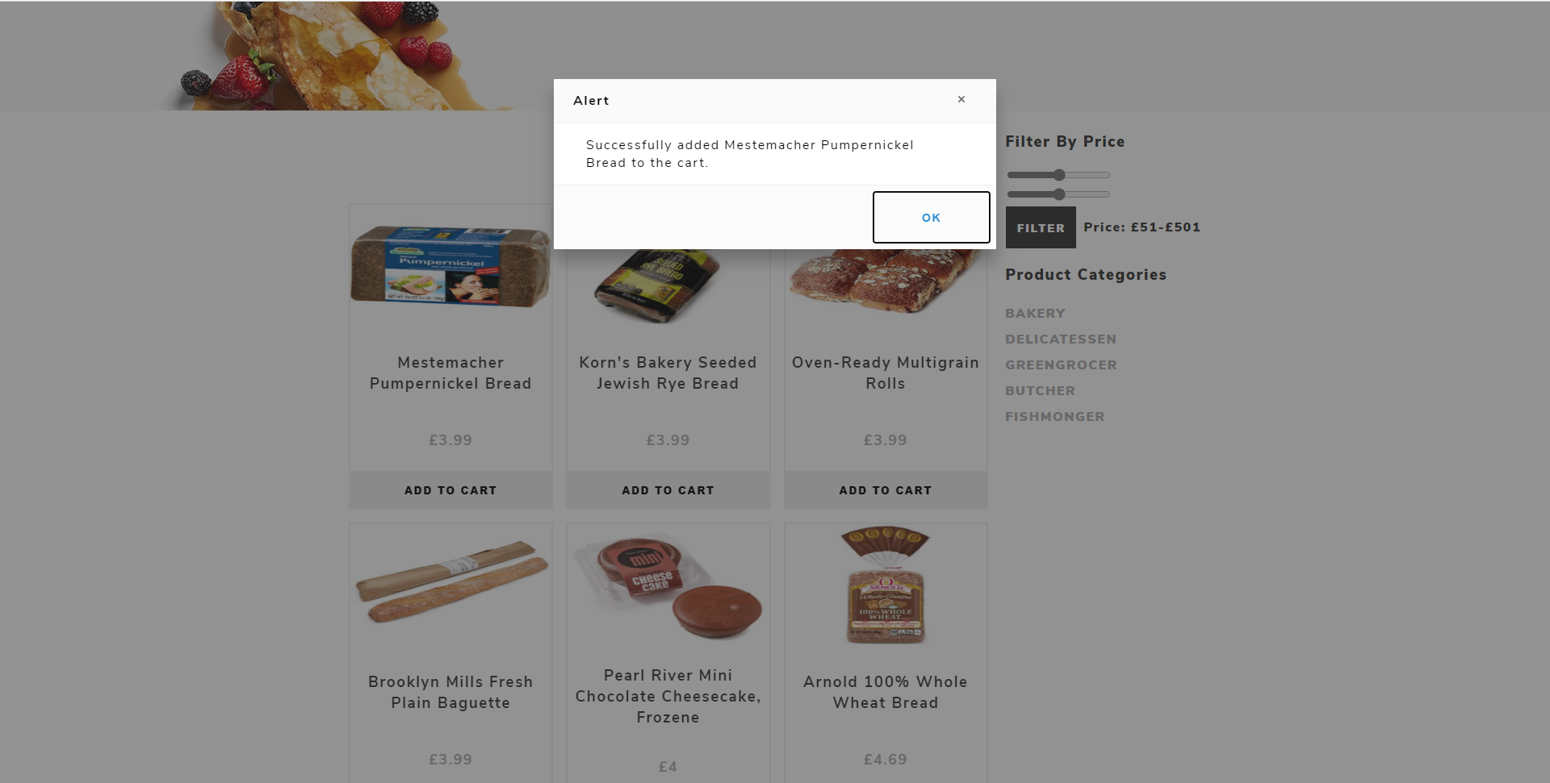

## Users can update the quantity of products in the basket

Expected Result: Product quantity is updated

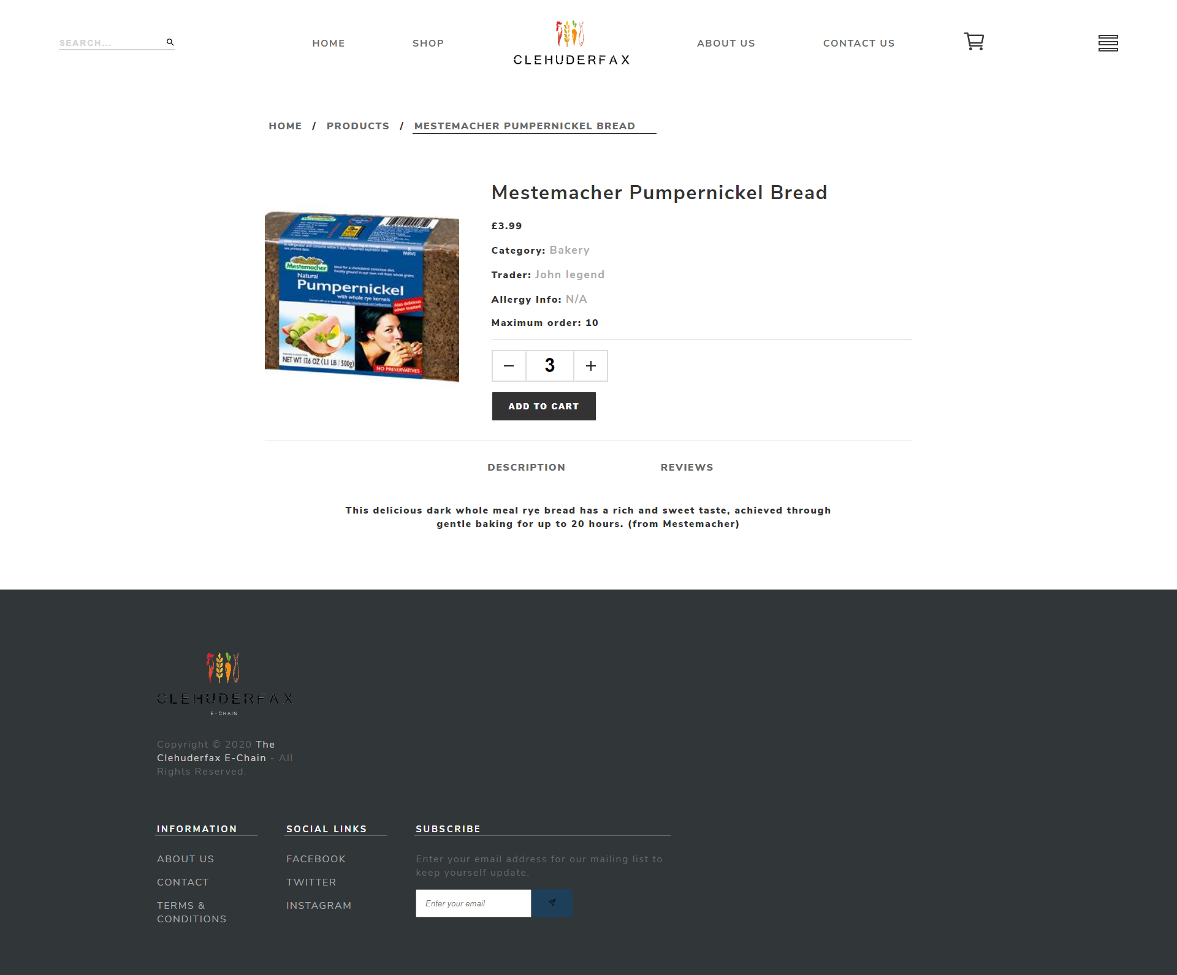

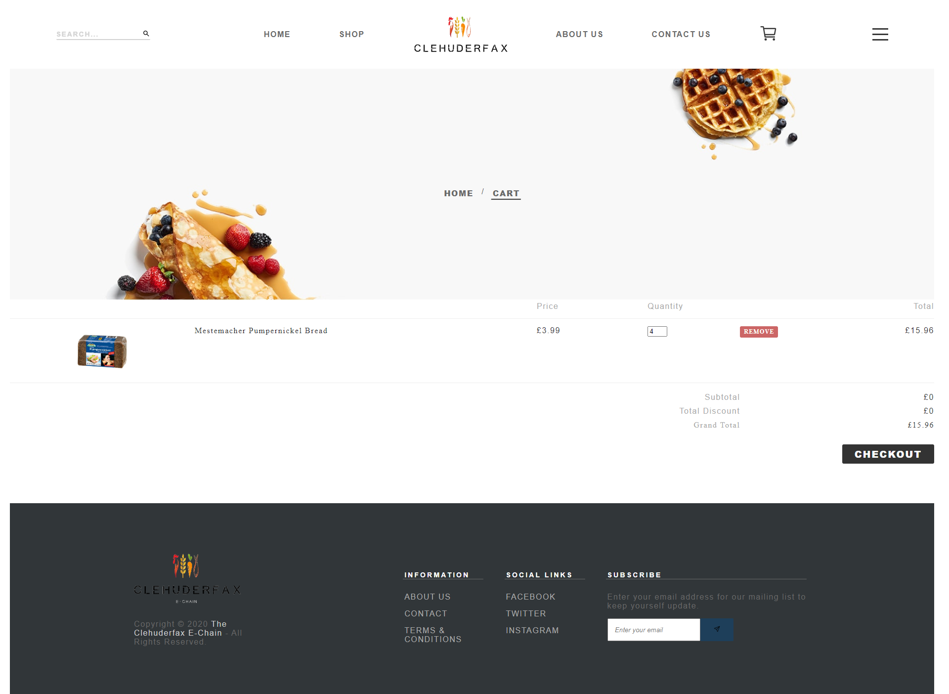

## Users can delete the product from the basket

Expected Result: Product is removed from the basket 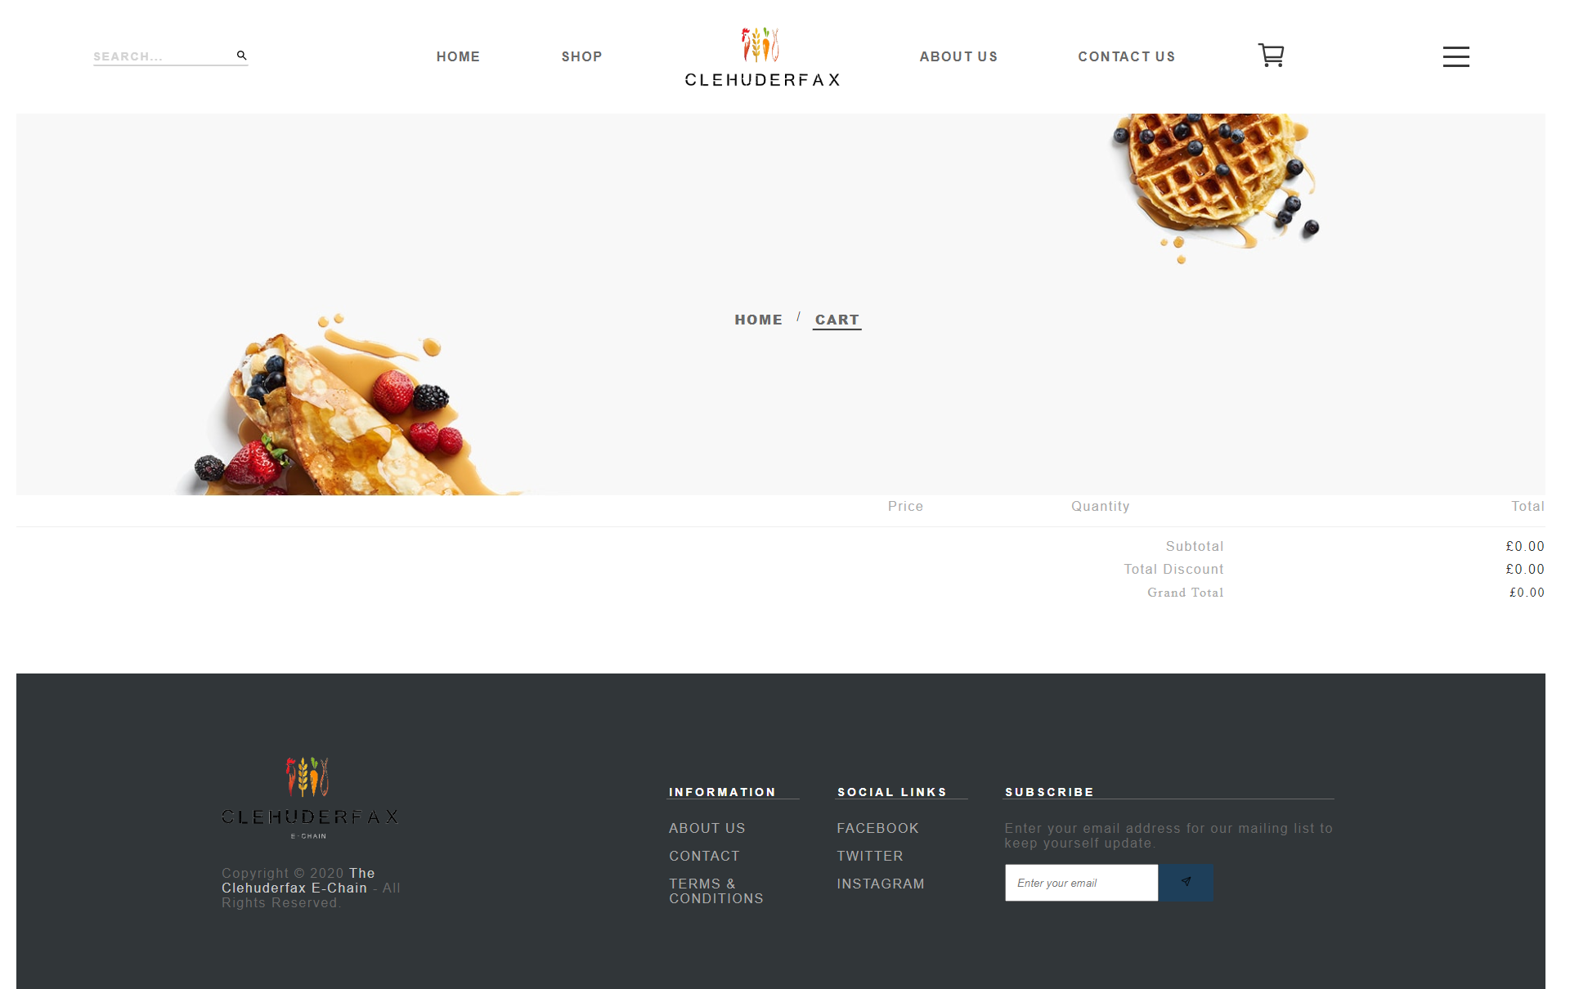

## Customers can view the basket with products, quantity and price.

Expected Result: Basket with required details is shown

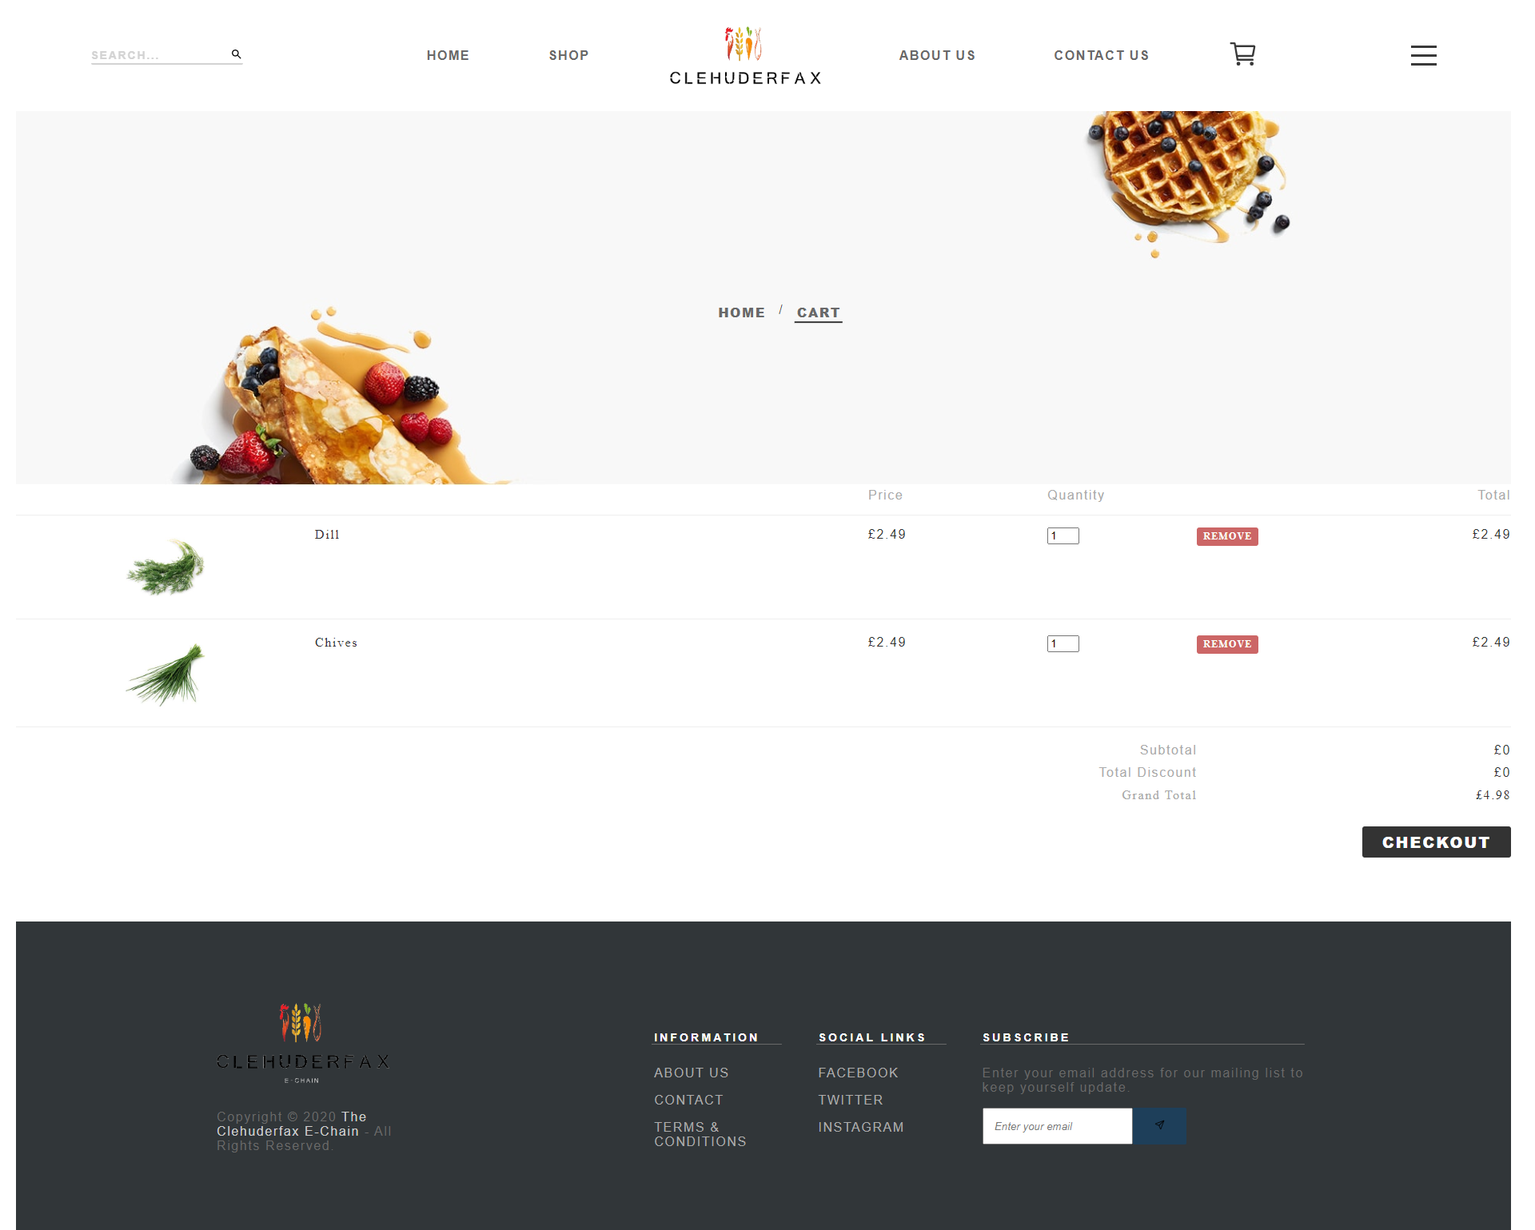

## Customers can select a collection slot before checking out and edit their details.

Expected Result: Customer is redirected to checkout page.

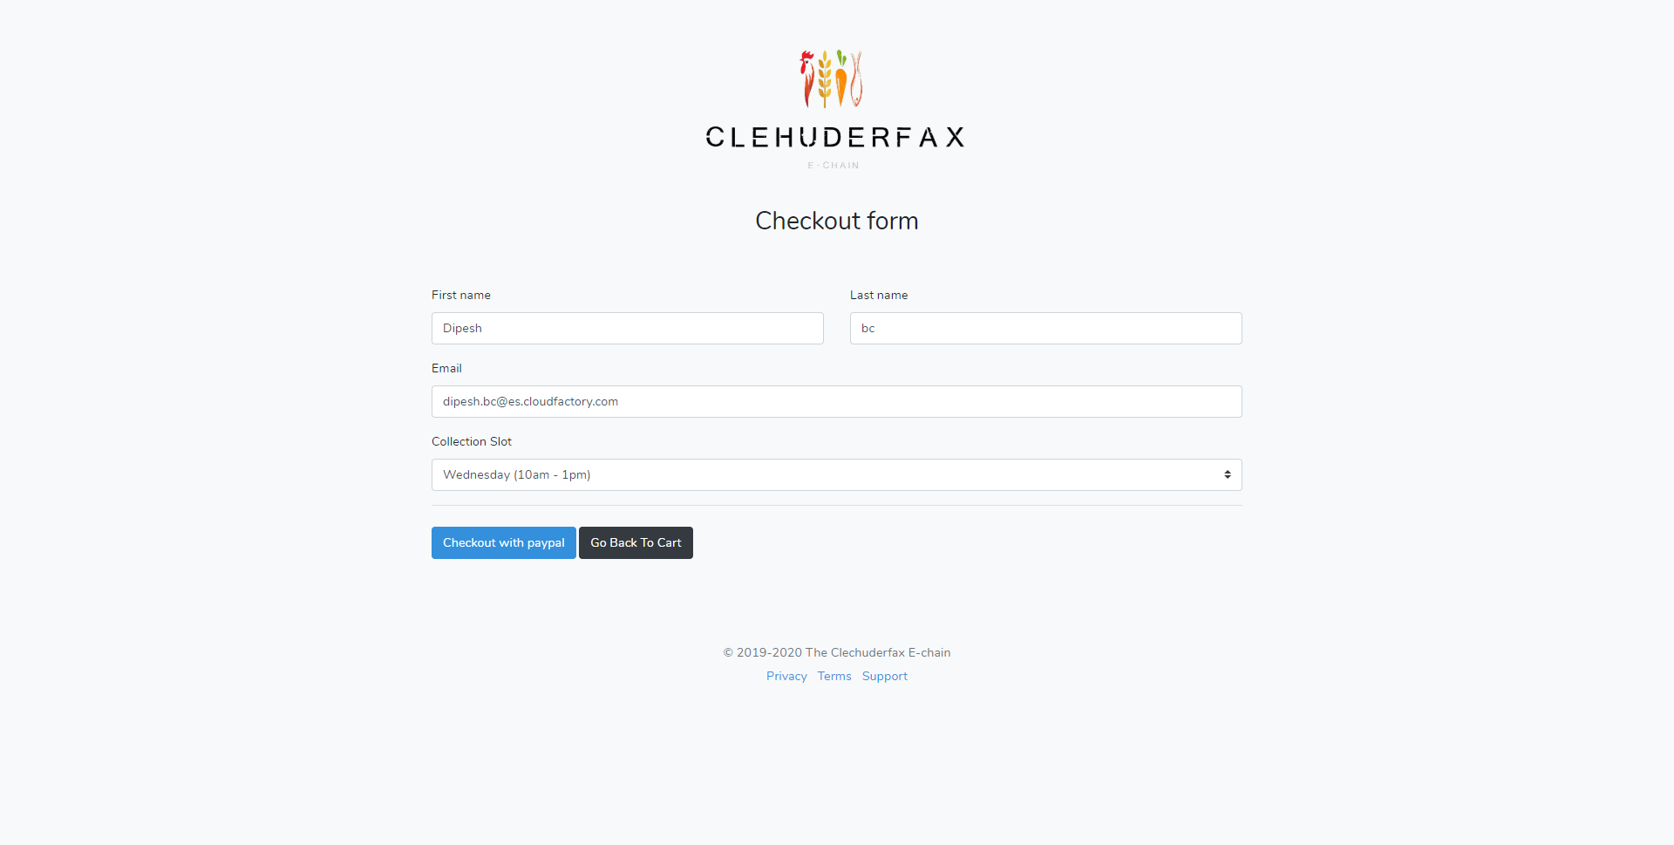

## Customers will receive a receipt of payment for their goods in their email once payment is confirmed

Expected Result: The customer receives the invoice/receipt

